**PRACTICAL 5**

**Network Virtualization (Dividing one LAN into 2)**

**Aim –** Create a LAN network with 4 PC’s and 1 switch. Using network virtualization convert one physical LAN in tow virtual LAN’s.

**Topology –**

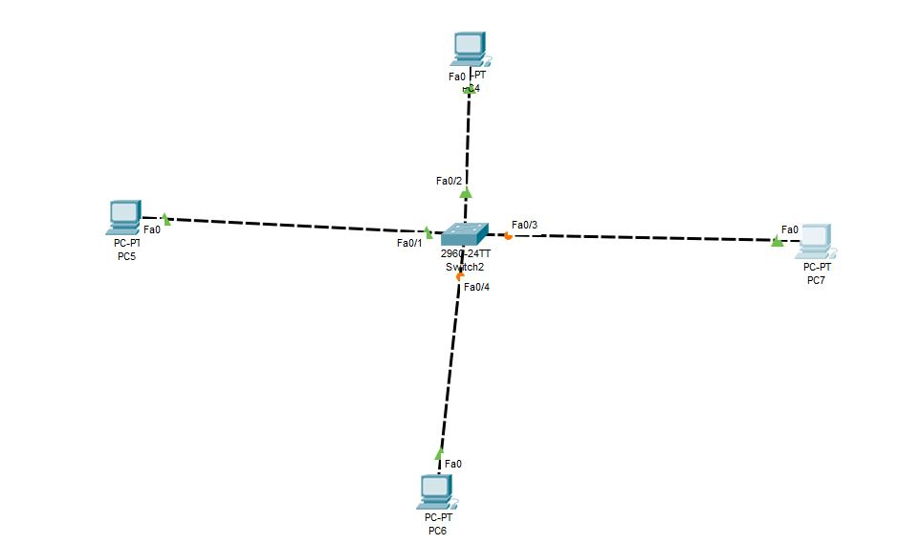

**Steps –**

*Step 1: Create Topology as shown above but do not assign the IP address to the PC.*

*Step 2: Start CLI for Switch and create tow vlans vlan red and vlan blue.*

**Syntax for creating VLAN:**

**vlan v_number**

**name v_name**

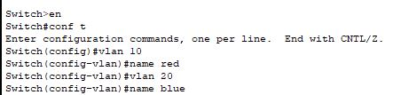

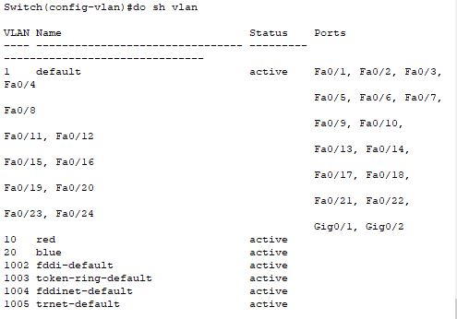

*Step 3: Now, start adding the PC’s to specific vlan*

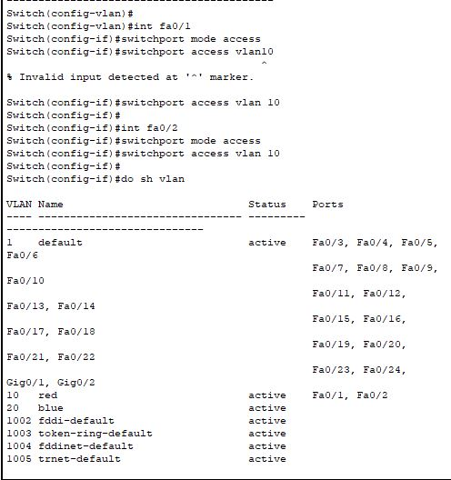

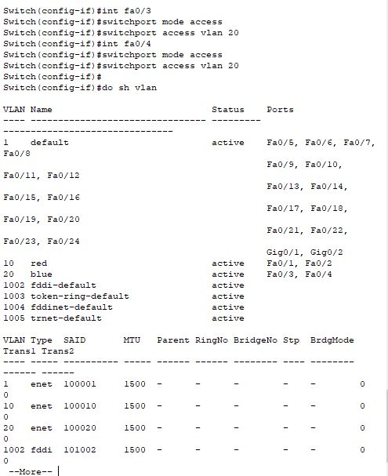

*Step 4: Now, When we will ping the PC’s from same VLAN they should give reply and for PC’s from different VLAN they won’t reply.*

**Same VLAN’s**

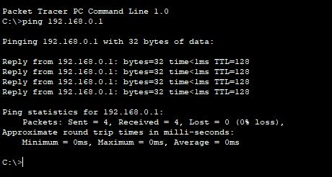

**Different VLAN’s**

